Set 19
Set 19: Survey Responses Analysis
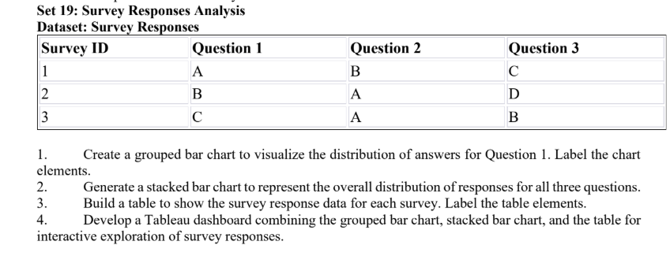
1. Grouped bar chart: Question 1
Aim: To show the frequency of each answer given to Question 1.
Code:
# Install these packages once if needed:
# install.packages(c("ggplot2", "dplyr", "tidyr"))
library(ggplot2)
library(dplyr)
survey <- data.frame(
`Survey ID` = c(1, 2, 3),
`Question 1` = c("A", "B", "C"),
`Question 2` = c("B", "A", "A"),
`Question 3` = c("C", "D", "B"),
check.names = FALSE
)
q1_counts <- survey %>%
count(`Question 1`, name = "Frequency")

ggplot(q1_counts, aes(x = `Question 1`, y = Frequency, fill = `Question 1`)) +
geom_col(width = 0.7) +
geom_text(aes(label = Frequency), vjust = -0.4) +
labs(
title = "Distribution of Answers for Question 1",
x = "Answer",
y = "Number of Responses",
fill = "Answer"
) +
theme_minimal()
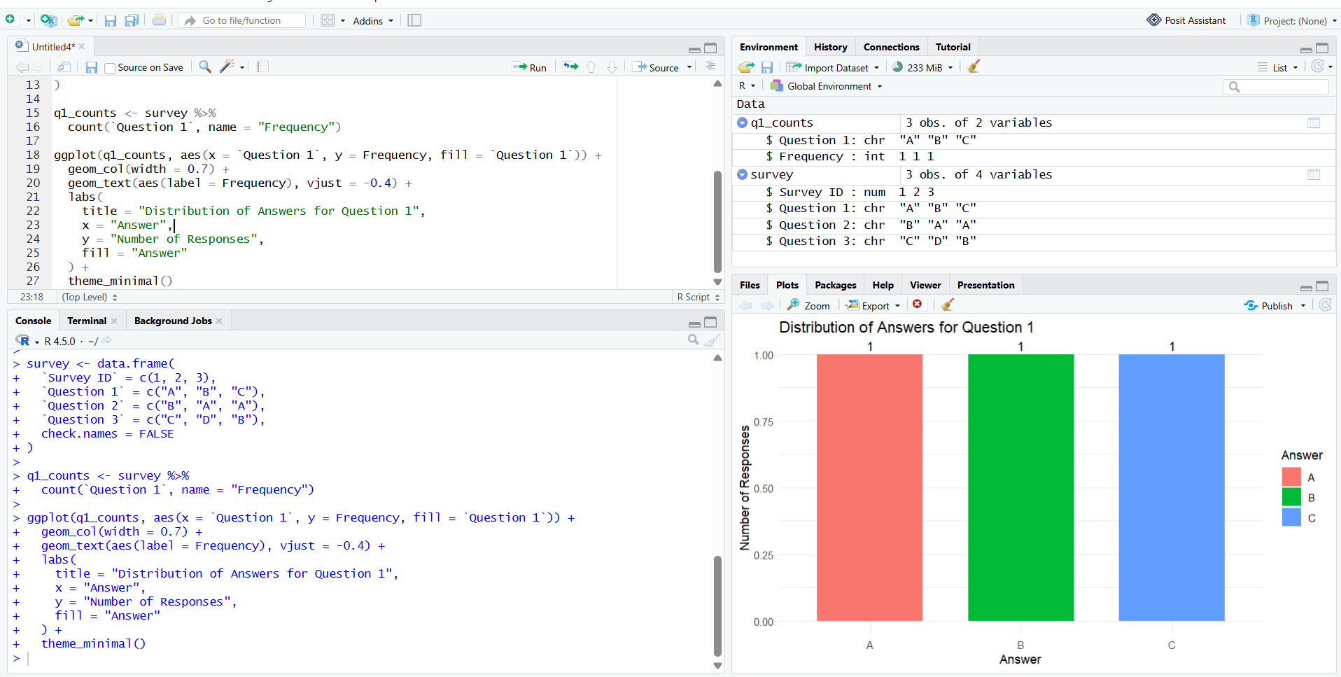2. Stacked bar chart: all three questions
Aim: To compare the distribution of answers across Questions 1, 2, and 3 using stacked bars.
Code:
library(tidyr)
survey_long <- survey %>%
pivot_longer(
cols = starts_with("Question"),
names_to = "Question",
values_to = "Answer"
)
ggplot(s
urvey_long, aes(x = Question, fill = Answer)) +
geom_bar() +
labs(
title = "Response Distribution Across All Questions",
x = "Question",
y = "Number of Responses",
fill = "Answer"
) +
theme_minimal()
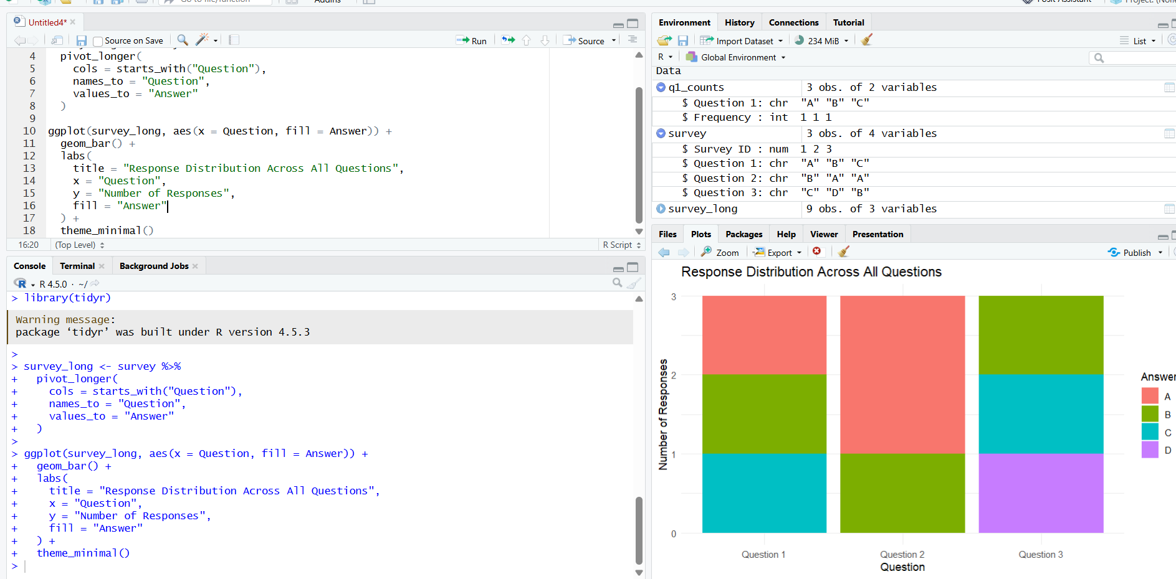
3. Labeled survey response table
Aim: To display each survey’s answers to all three questions in a clearly labeled table.
Code:
# Create the survey response data
survey <- data.frame(
"Survey ID" = c(1, 2, 3),
"Question 1" = c("A", "B", "C"),
"Question 2" = c("B", "A", "A"),
"Question 3" = c("C", "D", "B"),
check.names = FALSE
)
# Display the table in the R console
print(survey, row.names = FALSE)
# Optional: open the table in RStudio's data viewer
View(survey)

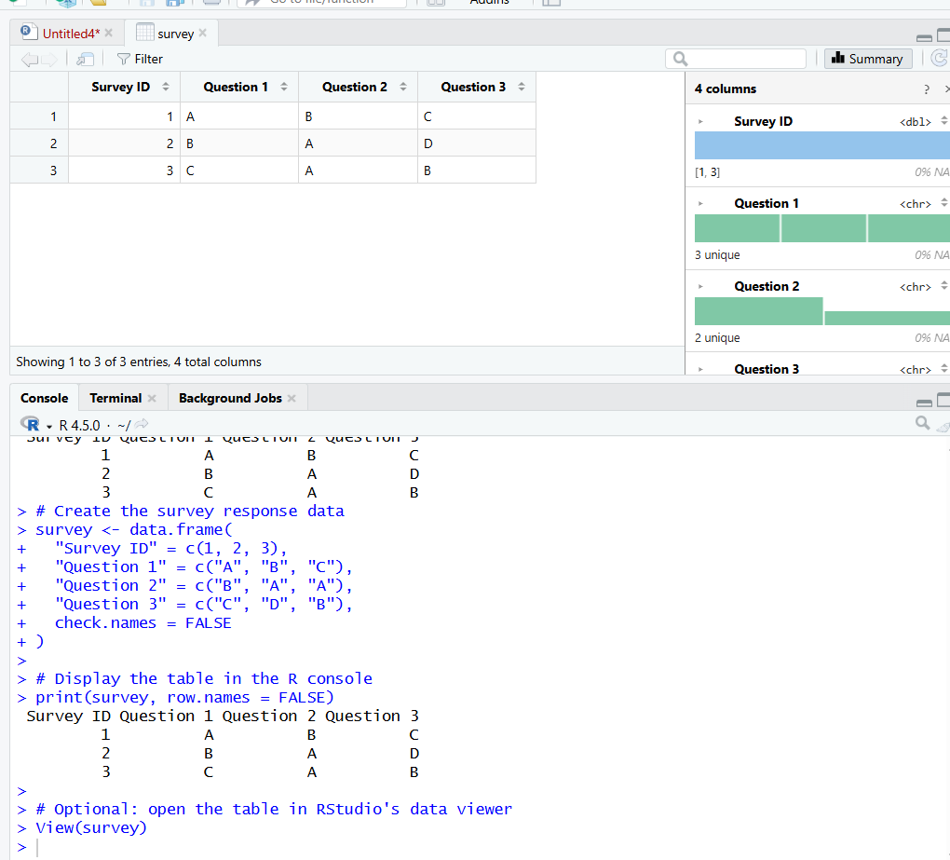
4. 